ANUSHERVON RAKHMATOV
201356375
CS4754 PROJECT
“afr741_4754”
http://www.cs.mun.ca/~afr741/
OCTOBER 27, 2017

- This “afr741_4754” project implements a simple web forms consisting of database queries and it employs client-server architectures. The idea is simple. Users enter inputs at the client side, via form[1-5].php. These inputs are then delivered to the web server for processing and the output which displays the table with retrieved data.

- To start the application go to http://www.cs.mun.ca/~afr741/afr741_4754/ :
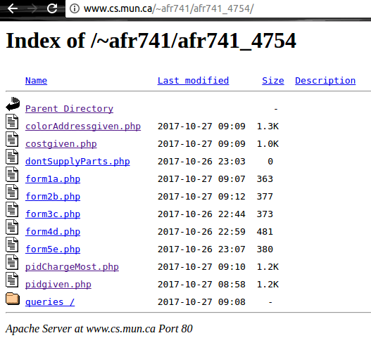

- Since there are 5 queries(a-e) that we need to implement, I created 5 Forms with a letter in their names that corresponds the query letter.
- To run each query, click on one of 5 forms. After clicking on one of 5 forms, there will be a heading which provides a short description of the current query. Enter the required query and click submit button and you will see the table with retrieved data.
- To use the same query with different value, clink “GO BACK” link.
- To use a different query, click on “GO TO THE MAIN MENU” link and choose a different form.

Screen-shots of sample run
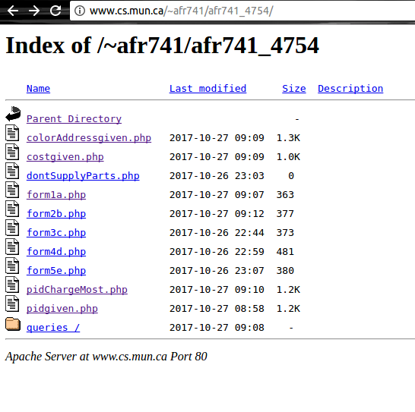

QUERY (a)
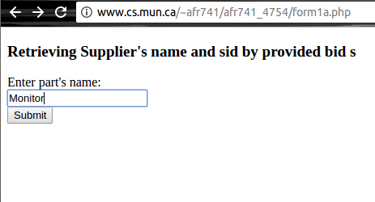

RESULT

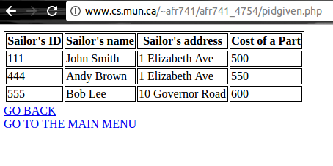

QUERY (b)
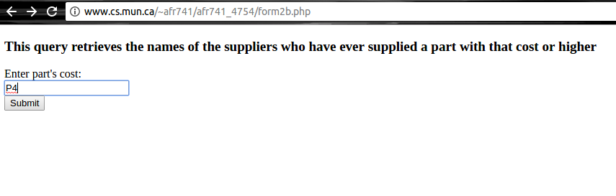

RESULT
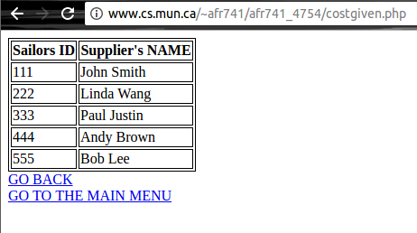

QUERY (c)
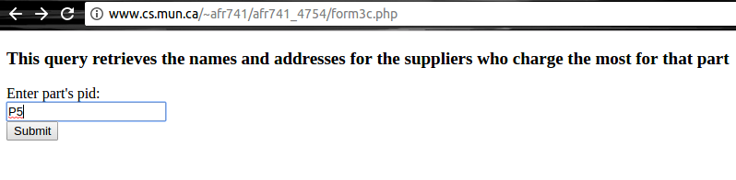
RESULT
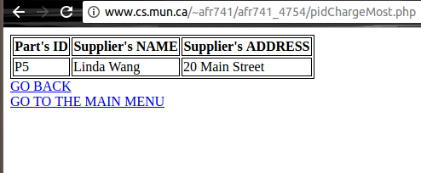

QUERY (d)
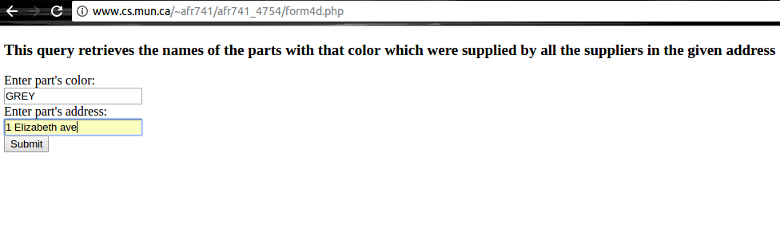
RESULT
